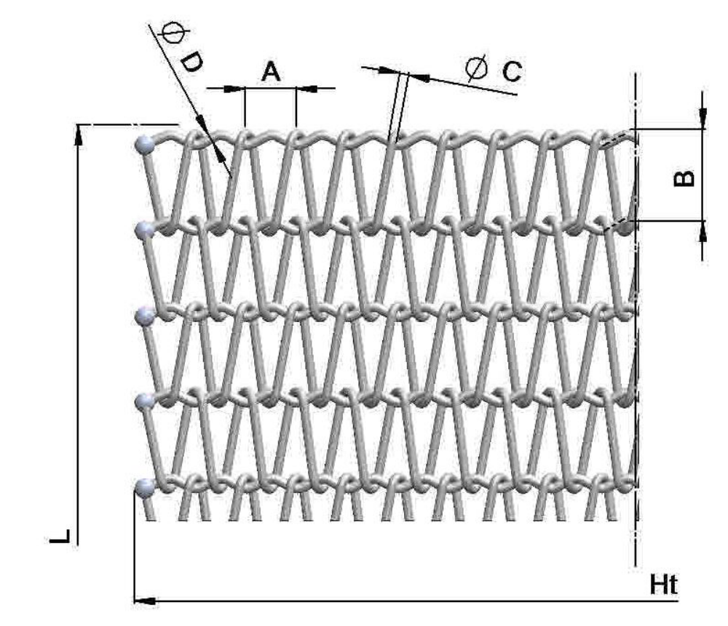

Type of steel | A mm.  Spirals pitch | B mm.  Distance between rods | C mm.  Spirals wire diameter | D mm.  Rods wire diameter | Ht mm.  Conveyor belt width | L mm.  Conveyor belt length
Ni-Cr 80/20

